# Report on Rest Web Service

Results

* Developed a Rest Web Service Interface and defined all methods declared in it
* Run "Service1.svc" on Local Machine to test arithmetic operations Add, Subtract, Multiplication and Division
* URL: <http://localhost:63082/Service1.svc>
* Add "/Operation Name/Number1/Number2" to URL mentioned above
* User can enter input values and can basic four operations
* Page displays with the output value
* Adding two numbers 10, 11 and the result is 21

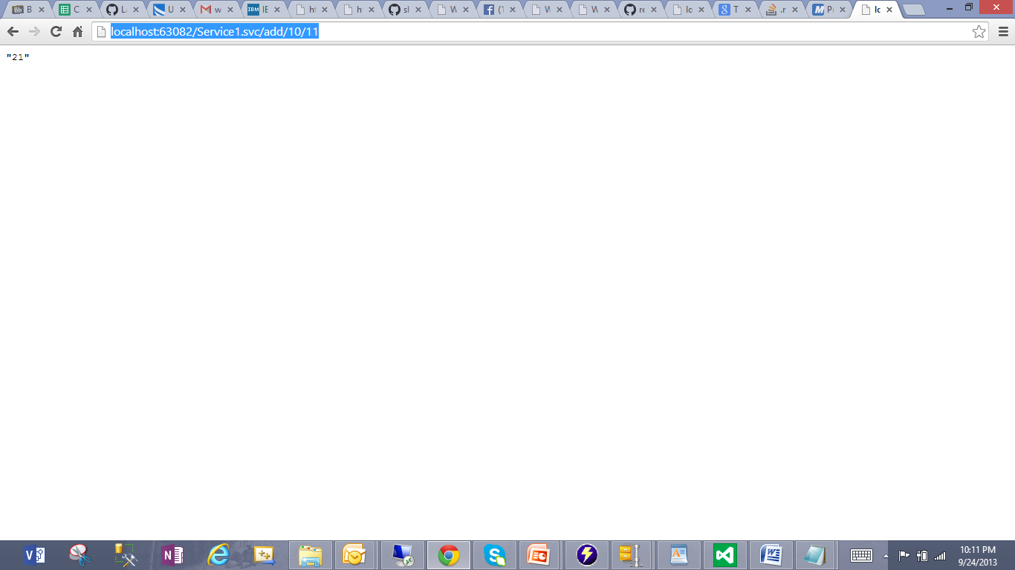

* Multiplying two numbers 10, 20 and the result is 200

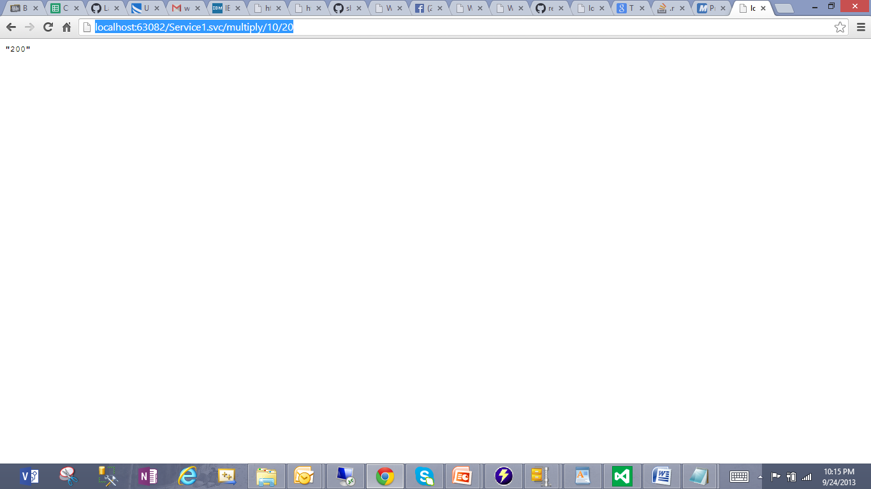

* Dividing two numbers 20, 2 and the result is 10

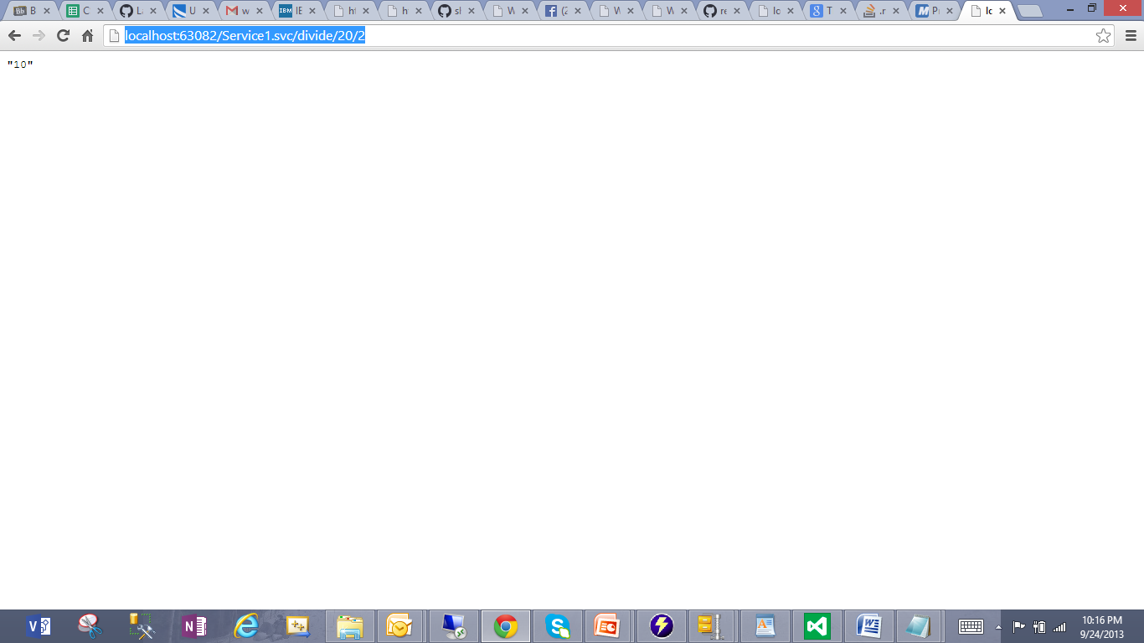

* Subtracting two numbers 20, 5 and the result is 15

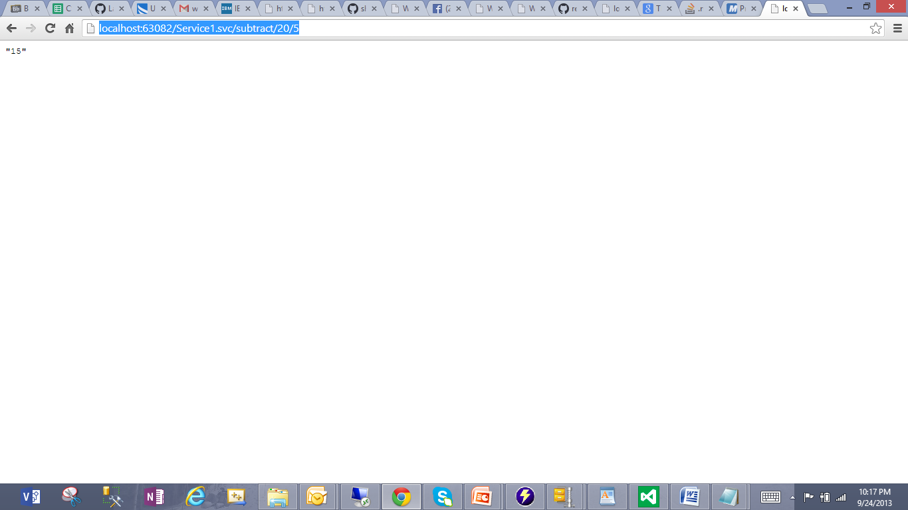

Deployed Rest Web Service into IBM Cloud instance

URL: <http://localhost/aspnet_client/RestService/Service1.svc>

* Browsed "Service1.svc" to invoke Rest web service on Remote Machine
* Adding two numbers 100, 200 and the result is 300

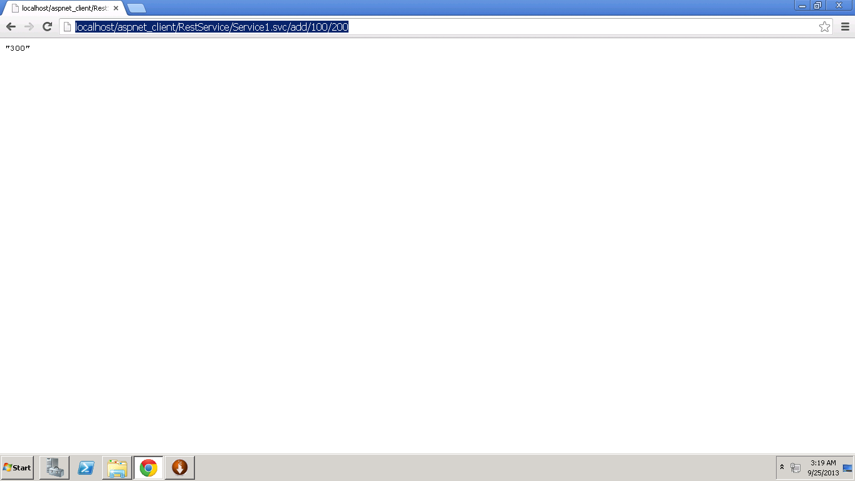

* Multiplying two numbers 100, 200 and the result is 20000

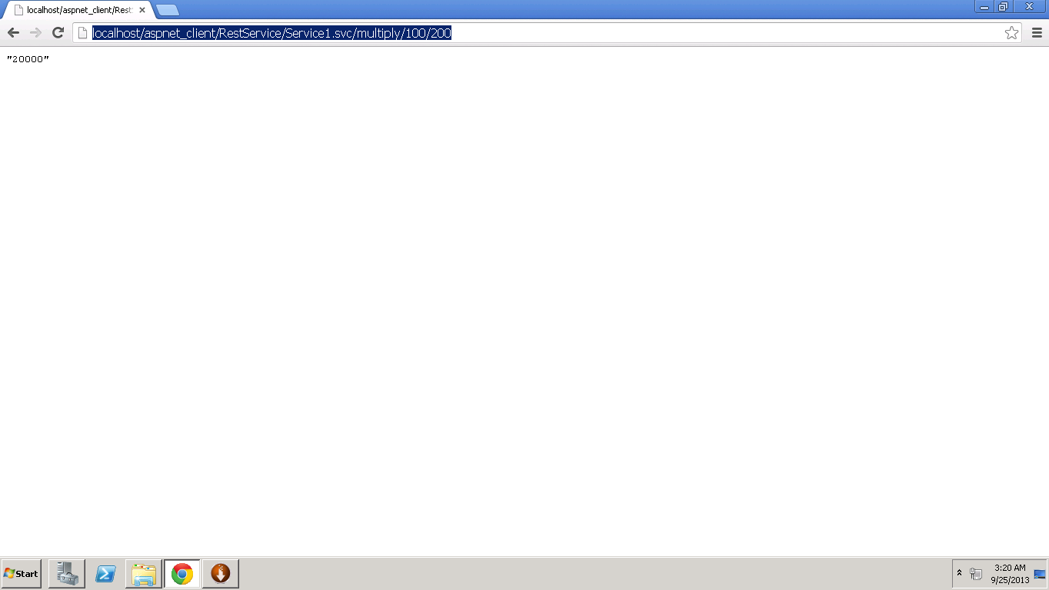

* Dividing two numbers 200, 100 and the result is 2

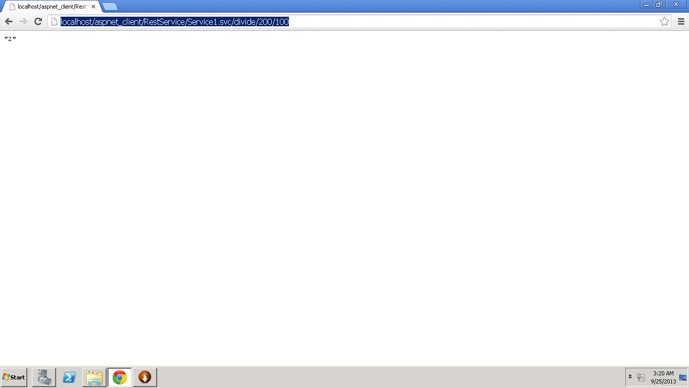

* Subtracting two numbers 500, 250 and the result is 250

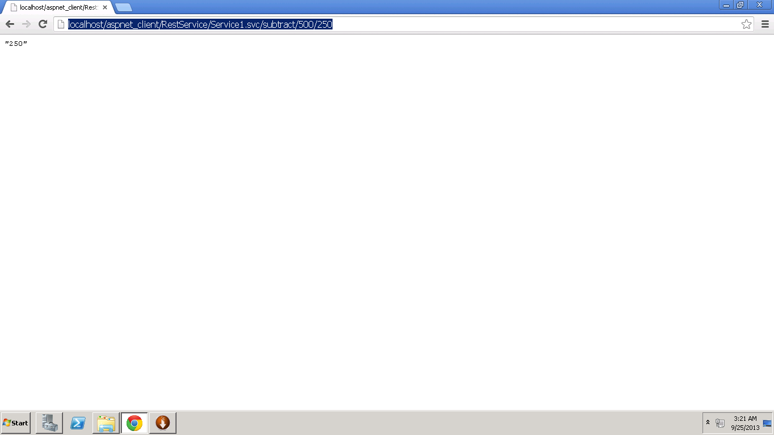

Accessing Remote Rest Service from Local Machine with my Cloud Instance IP Address 170.224.163.112

URL: <http://170.224.163.112/aspnet_client/RestService/Service1.svc>

* Adding two numbers 10, 20 and the result is 30

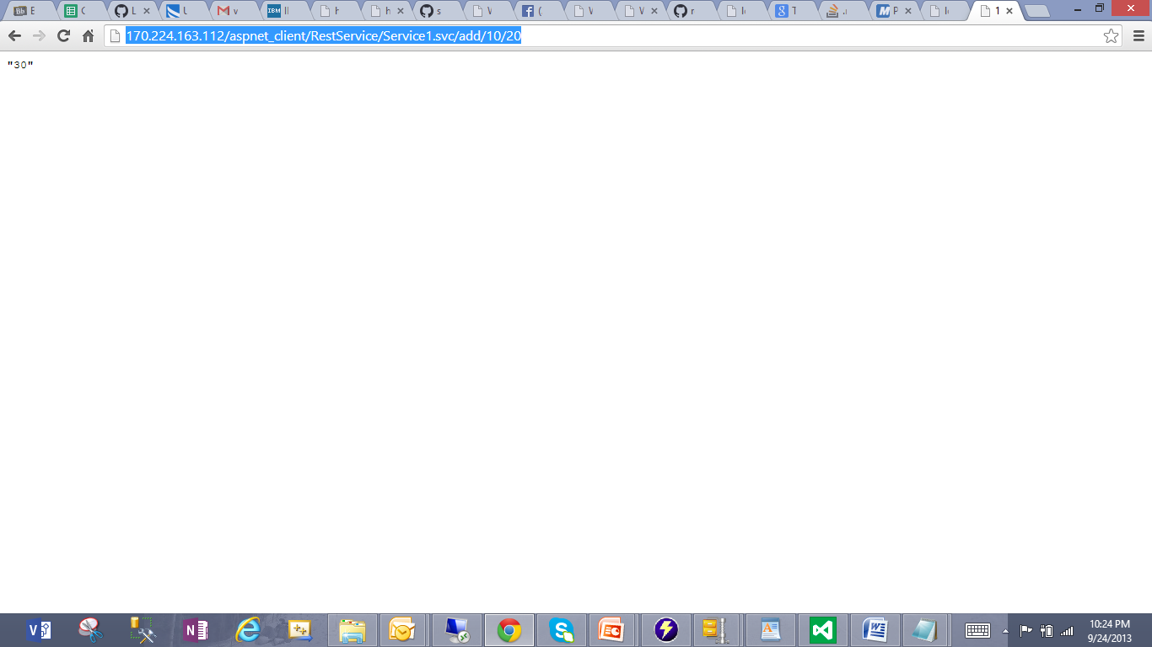

* Multiplying two numbers 10, 20 and the result is 200

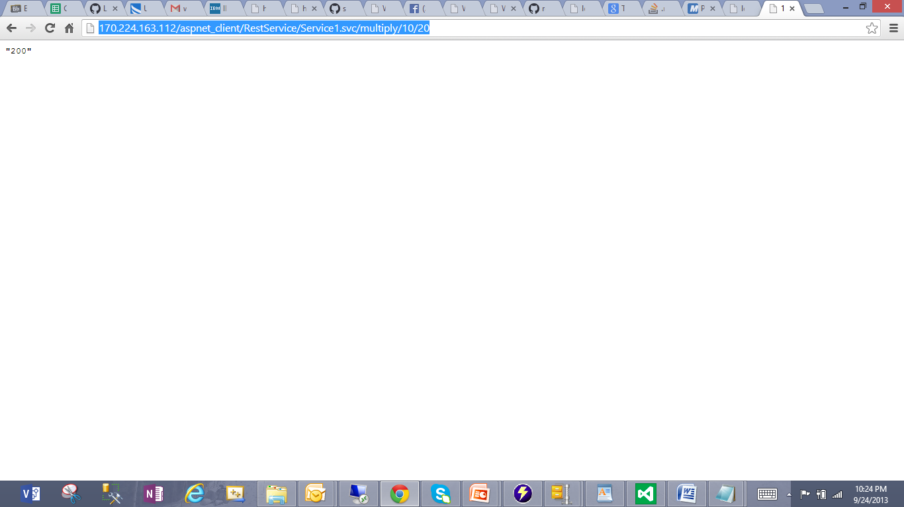

* Dividing two numbers 10, 20 and the result is 0 (Result is Integer type)

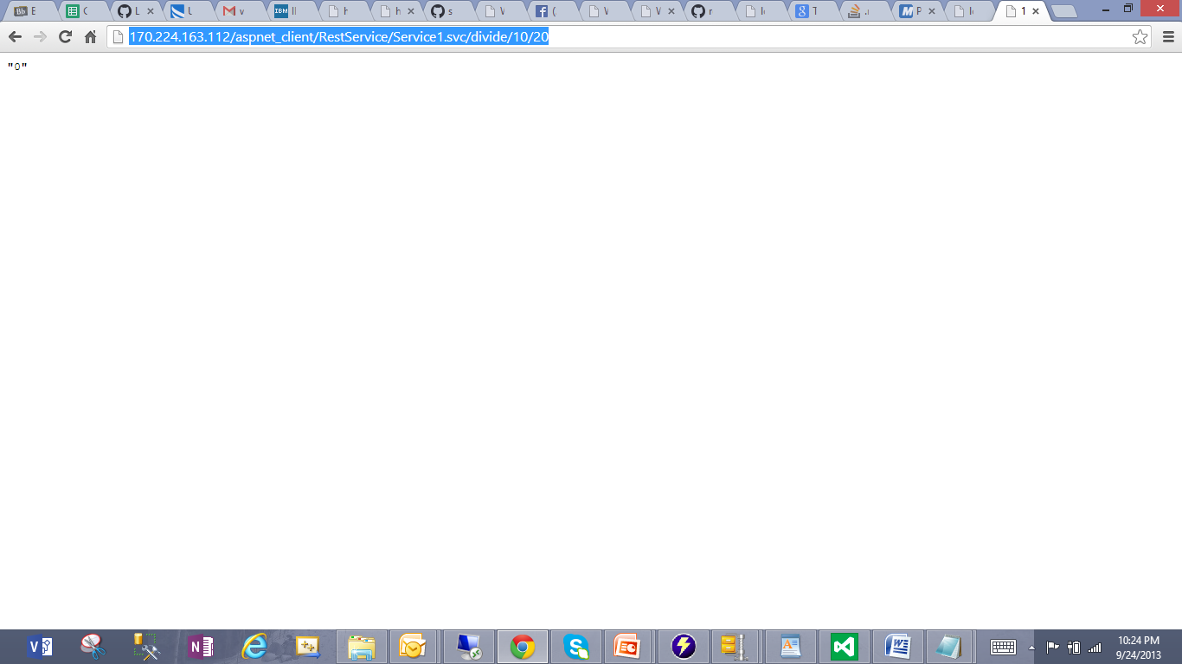

* Subtracting two numbers 10, 20 and the result is -10

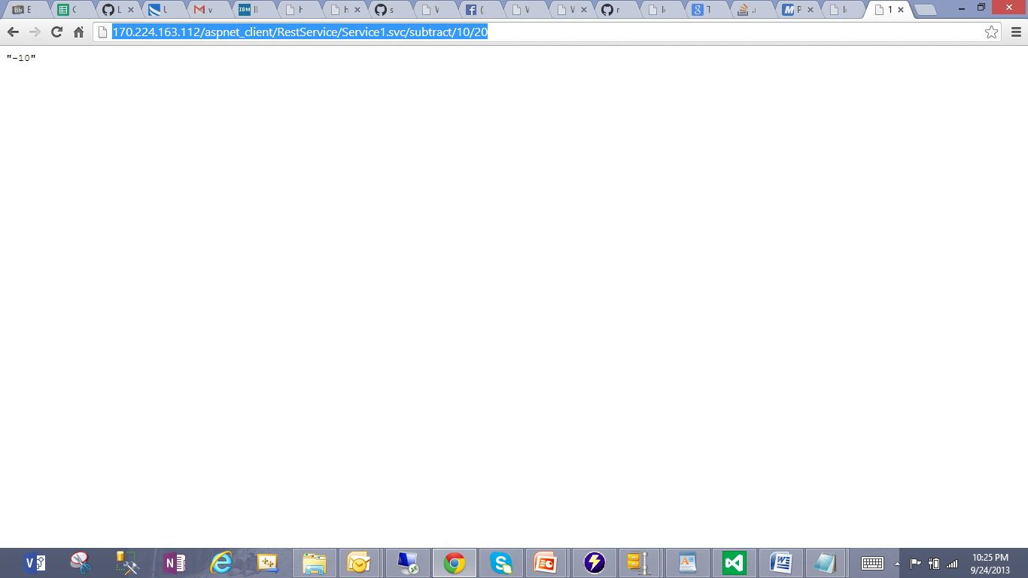

Observations:

* Implemented Restful Web Service on my local machine
* Deployed and run on IBM Cloud Instance
* Accessed Remote web service from the Local Machine
* Source code works well on both machines